Foursight Car Rental Management System
Group Name: Foursight
Members: Digamon, Jazen Gabriel Justol, Miguel Vincent
Quinlog, Ma. Hannah Lovely

Project Overview & Requirements

Executive Summary
The Foursight Car Rental Management System is a
consolebased C application designed to automate car rental operations
using barcode technology, file-based

storage, automated receipt printing, and email notifications.

Target Audience
Small to medium car rental businesses, rental clerks and administrators, and students evaluating C-based systems. Functional Requirements
Register and manage users, customers, cars, and rentals; generate and read barcodes; store records in files; print and email receipts.

Non-Functional Requirements
Fast performance, secure login,
reliable data handling, simple console UI, and portability.

System Architecture & Design

System Overview
The Foursight Car Rental Management System is a
consolebased application built using the C programming language. It uses file handling for persistent storage and integrates external libraries for barcode generation and email
communication.

Architecture Description Frontend:
Console-based user interface
Backend Logic: Core C functions for processing rentals, users, and cars Data Storage: Text files using
structured formatting External Libraries: Zint (barcode generation) libcurl (email sending via SMTP) Data Relationships

(Conceptual) One user can manage many rentals One car can be rented multiple times (at different periods) Each rental is associated with one customer and one car

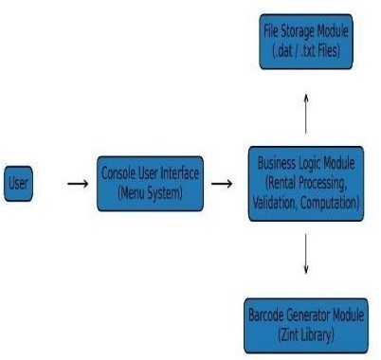

Installation & Setup Guide

Prerequisites
C Compiler (GCC recommended)
Zint Library libcurl Library Operating System with printer support

Step-by-Step Installation
- Install GCC compiler
- Install Zint and libcurl libraries
- Place the project source files in one directory 4.Compile the project using the appropriate compiler
command 5.
Run the executable file from the terminal or command prompt Environment Variables

Ensure library paths for Zint and libcurl are correctly configured No sensitive credentials are hard-coded in the system

User Manual & API Documentation

User Guide
The system provides a menu-driven console interface that allows users to: Log in securely Add, view, edit, and delete records Generate and scan barcodes Print and email rental
receipts

Core Functions
(API Overview) findCarByBarcode()

– Locates car records using barcode value generateBarcodePNG() – Generates barcode images using Zint autoPrintReceipt() –
Automatically prints rental receipts
sendEmailLibCurl() – Sends receipts via email saveUsers(), saveCars(),
saveRentals() – Store data to files loadUsers(), loadCars(), loadRentals()
– Load data from files

Known Issues
Barcode scanning depends on
accurate barcode input Email sending requires proper SMTP configuration

Testing & Quality Assurance

Testing Strategy
Manual testing of all system features Functional testing for file operations, printing, and emailing.

Sample Test Cases
Feature Input Expected Result Actual Result Barcode Generation Car ID PNG barcode created Successful File
Saving New rental Data saved to file Successful Email Sending Valid
email Receipt sent Successful.

Coverage Summary
All core system features were tested manually to ensure reliability and correctness.

Project Reflection (Student Perspective)

Challenges
Overcome The most challenging aspect was integrating external
libraries such as Zint and libcurl with a C-based system while maintaining stable file operations.

Future Enhancements
If given additional development time, the system could include: A graphical user interface (GUI) Database
integration (MySQL or SQLite) Realtime barcode scanning using hardware devices.

Lessons Learned
The project enhanced skills in: File handling and structured data storage Using external C libraries System integration and modular
programming.

Glossary of Terms
Barcode: A machine-readable code representing car information File
Handling: Reading and writing data to files SMTP: Protocol used for
sending emails Zint: Open-source barcode generation library libcurl: Library for transferring data with URLs

Source Code
The complete source code includes all program files and functions used in the system, such as: User
management modules Car and rental management modules Barcode
generation and reading modules Printing and email modules (All source code files are printed and
included in the appendix section of the softbound documentation.)


Memebers:

Fullname: Jazen Gabriel M. Digamon Address: Camella Homes Bohol
School name: University of Bohol Course: Bachelor of science in
computer engineering 1st yr

Email: jazdigamon12@gmail.com Number:09958836495



Fullname: Ma. Hannah Lovely A. Quinlog
Address: Alicia, Bohol
School name: University of Bohol Course: Bachelor of Science in

Computer Engineering 1st yr Email: mhlaquinlog@universityofbohol.edu. ph
Number: 09499729002



Fullname: Miguel Vincent Justol Address: Purok 3, Libertad,
Baclayon, Bohol
School name: University of Bohol Course: Bachelor of Science in

Computer Engineering 1st year
Email:
mvjustol@universityofbohol.edu.ph Number: 09817953721

sizDocumentation Pictures:
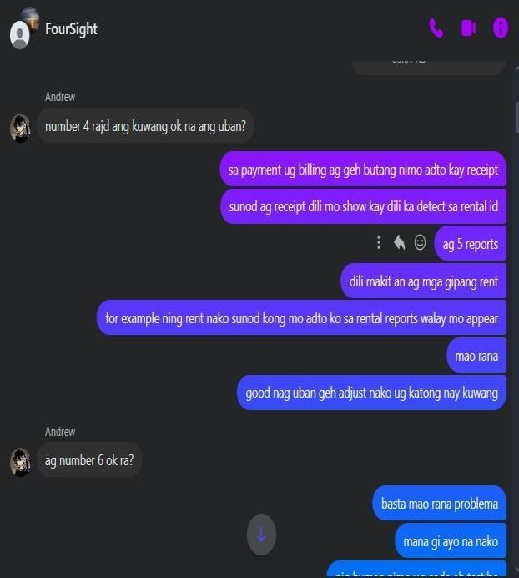

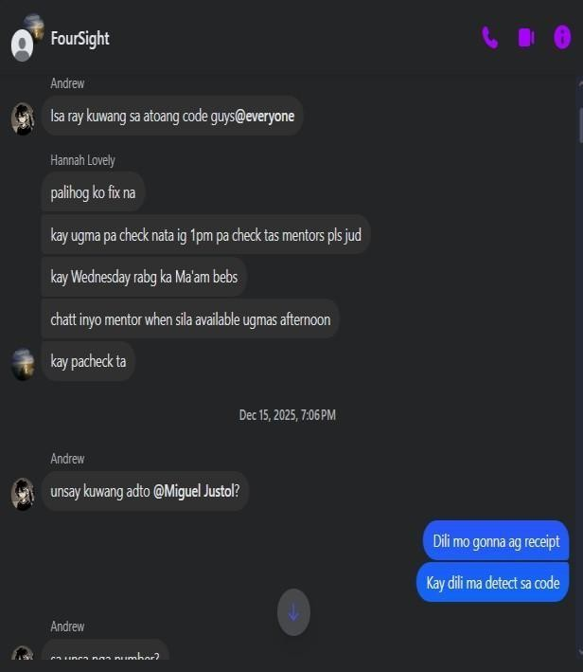

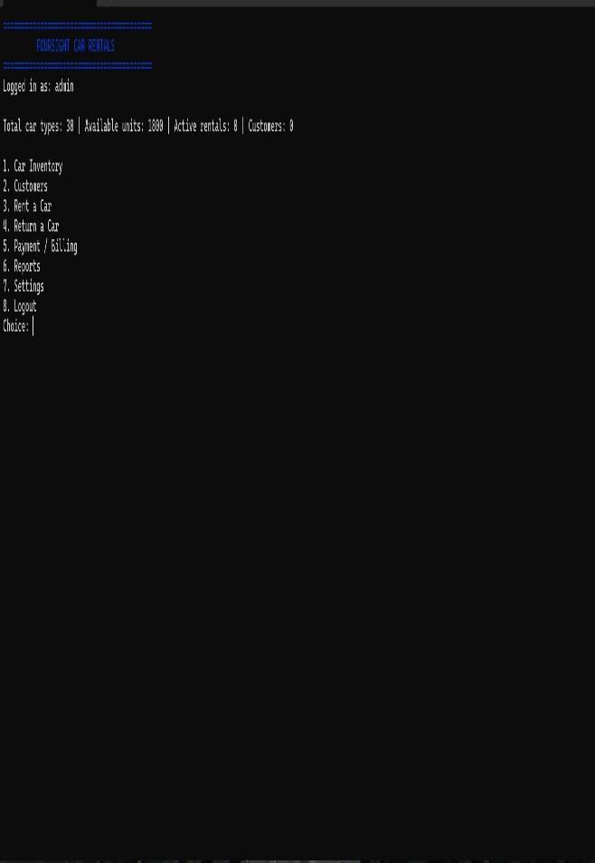

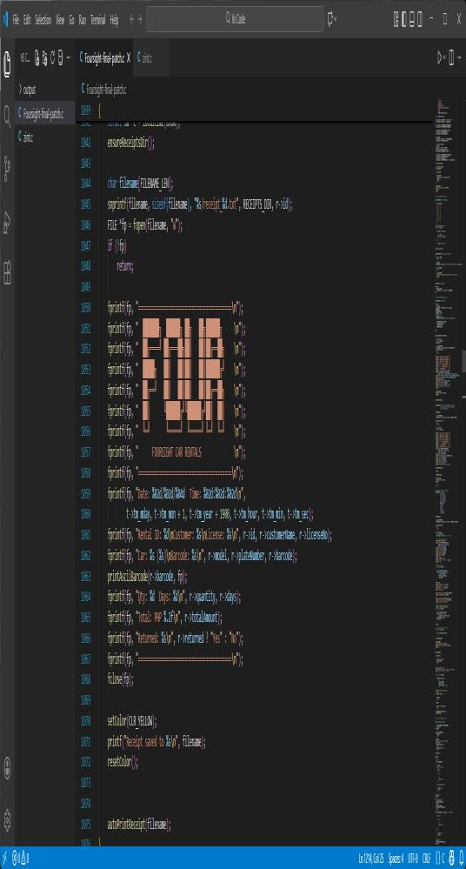

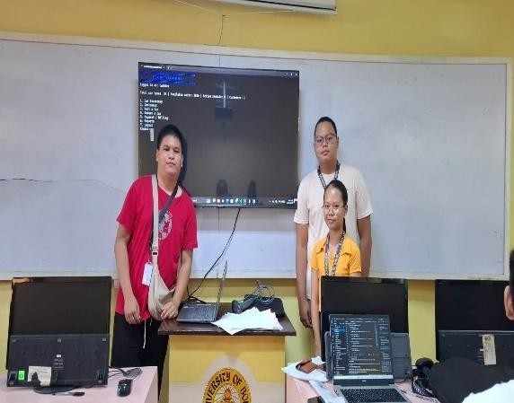

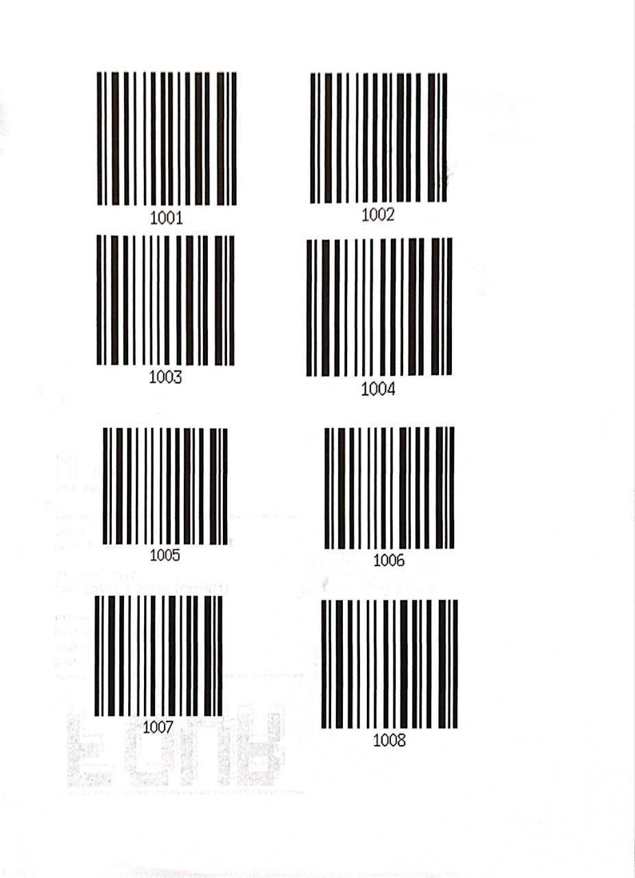
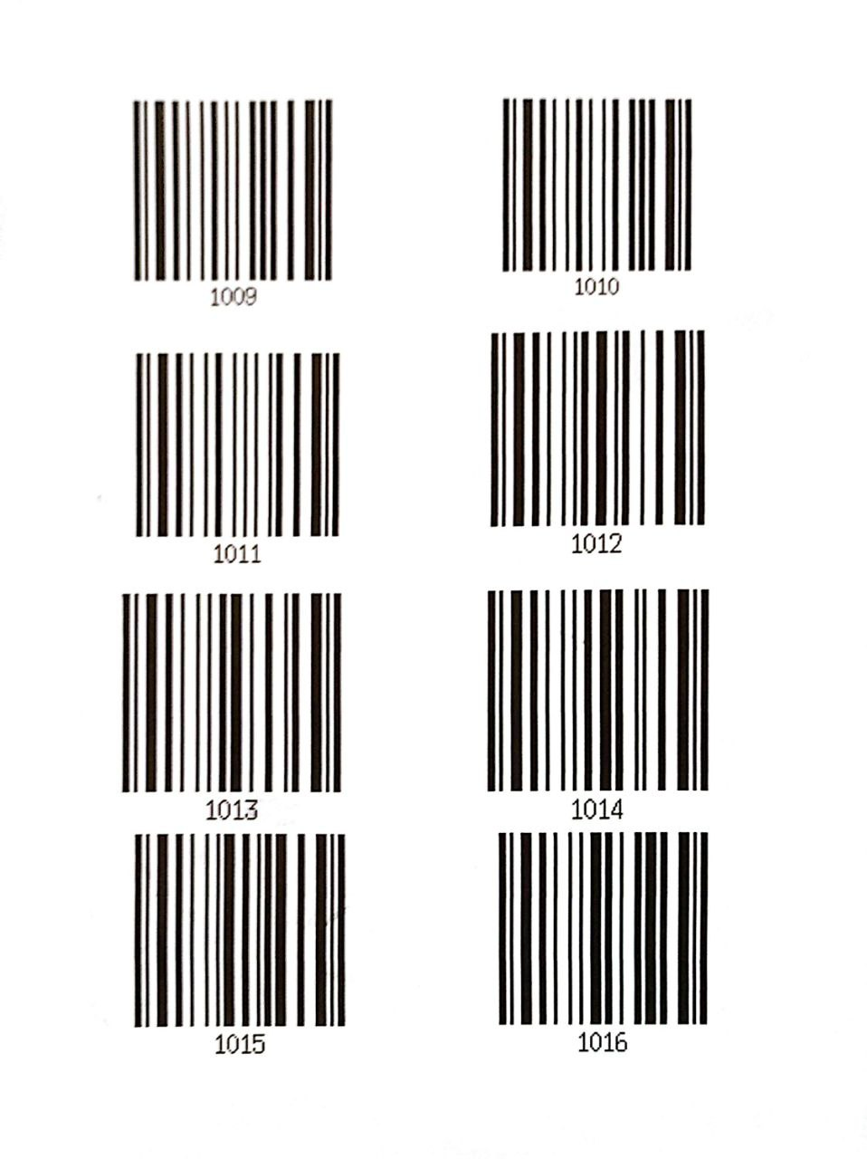
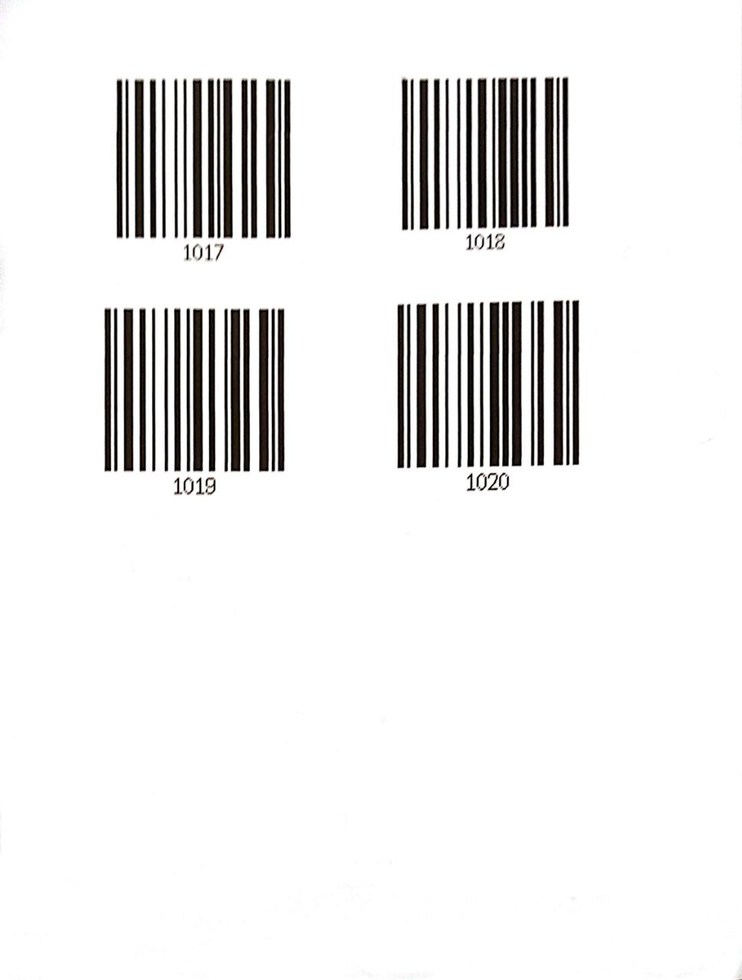
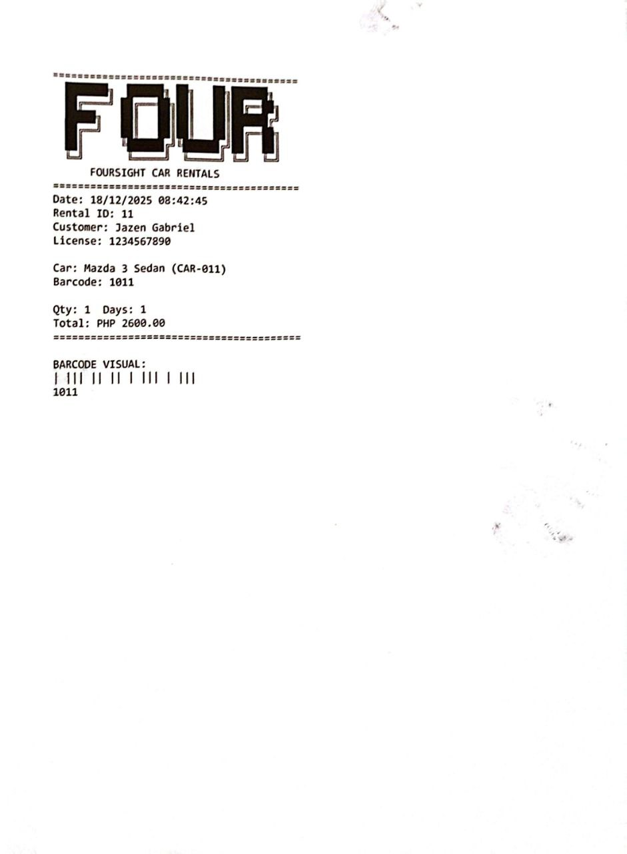
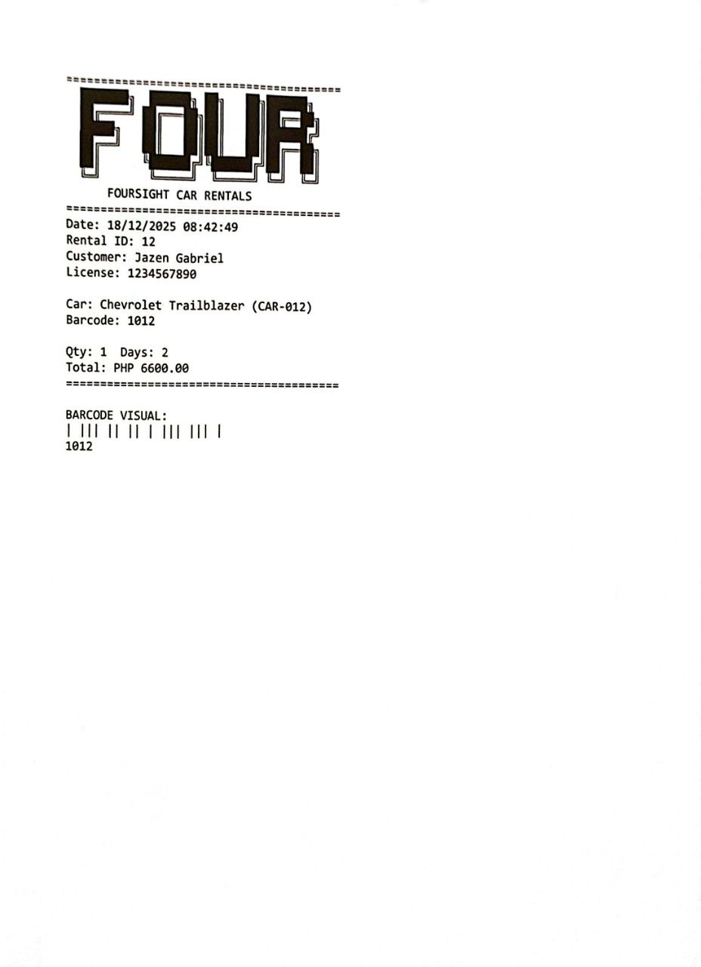
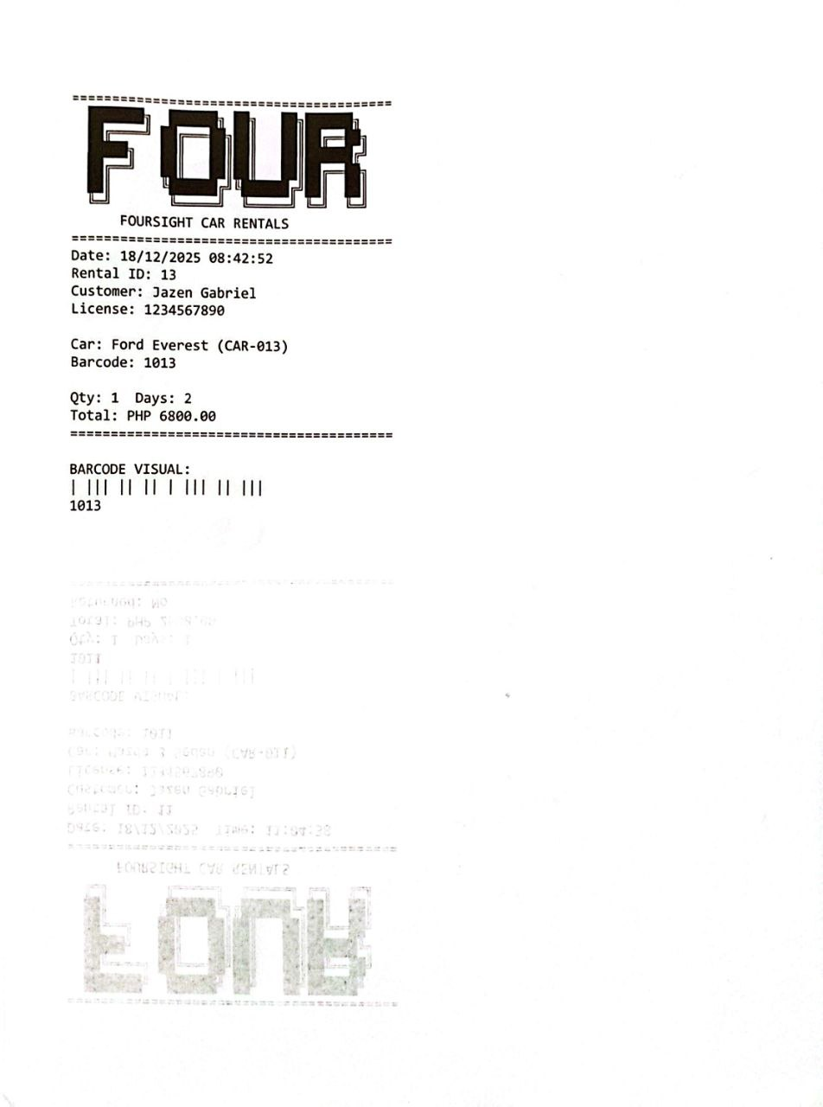

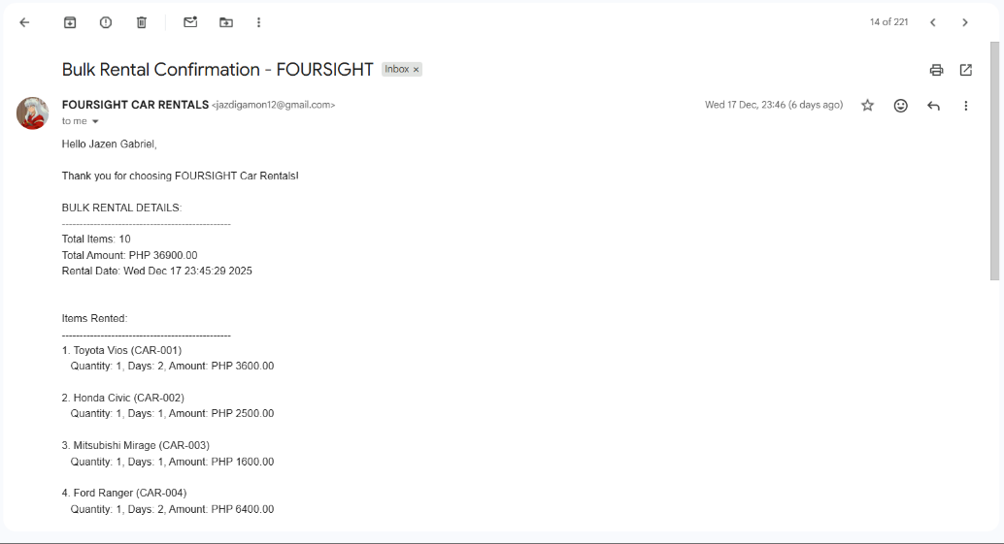

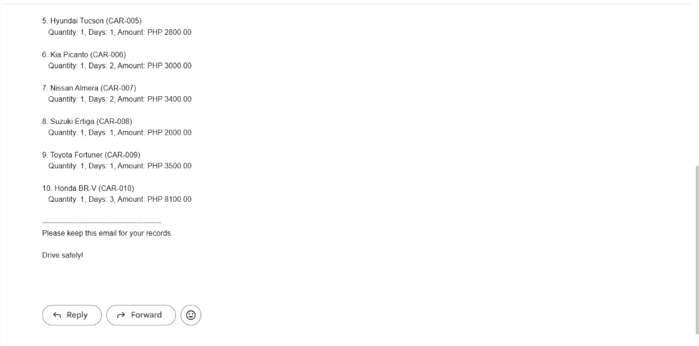

Rubrics:
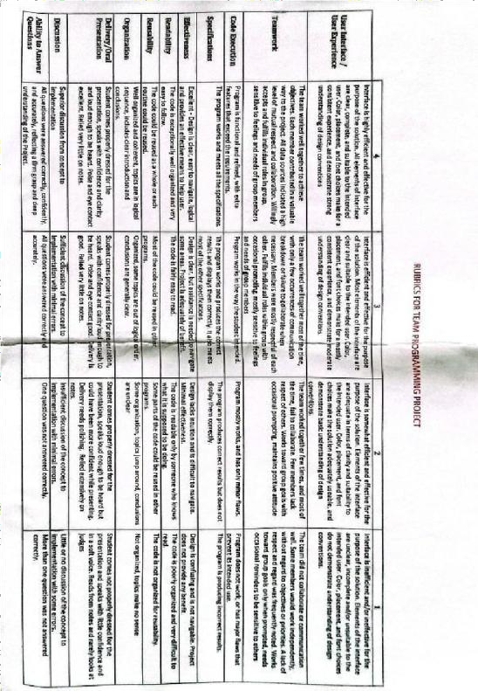

Rating Sheets:
